**ECE 4760**

**Final Project: Pico-Fight (Combat Game)**

By Albert Sun (ays48), Edwin Dake(ed433), Zoey Mo (zm73)

**Introduction**

Our final project for ECE 4760 is a strategic two-person combat game inspired by the open source fighting game "Footsies", a simple game designed to test the players spacing, timing and combat skills.

Our build leverages the Raspberry Pi Pico microcontroller connected to a VGA screen for visual display, with player input handled through keypads inputs. The game allows players to execute a variety of combat maneuvers, including attacks, blocks, shields, jumps, and crouches. The combat takes place in the critical "no man's land" between fighters, where positioning and tactical decisions determine victory or defeat. The Pico microcontroller processes player inputs with minimal latency, ensuring a responsive and fair competitive experience. Whether you're trading blows at mid-range or executing a perfect defensive maneuver, the system offers an engaging and intuitive gaming experience that captures the strategic depth of spacing-based combat games.

**Playthrough Demo**

[**https://youtu.be/TFvBpbWbc1k**](https://youtu.be/TFvBpbWbc1k)

**High-level Design**

Pico-Fight is a 2 player fighting game with each player being controlled by a keypad. When the game starts,

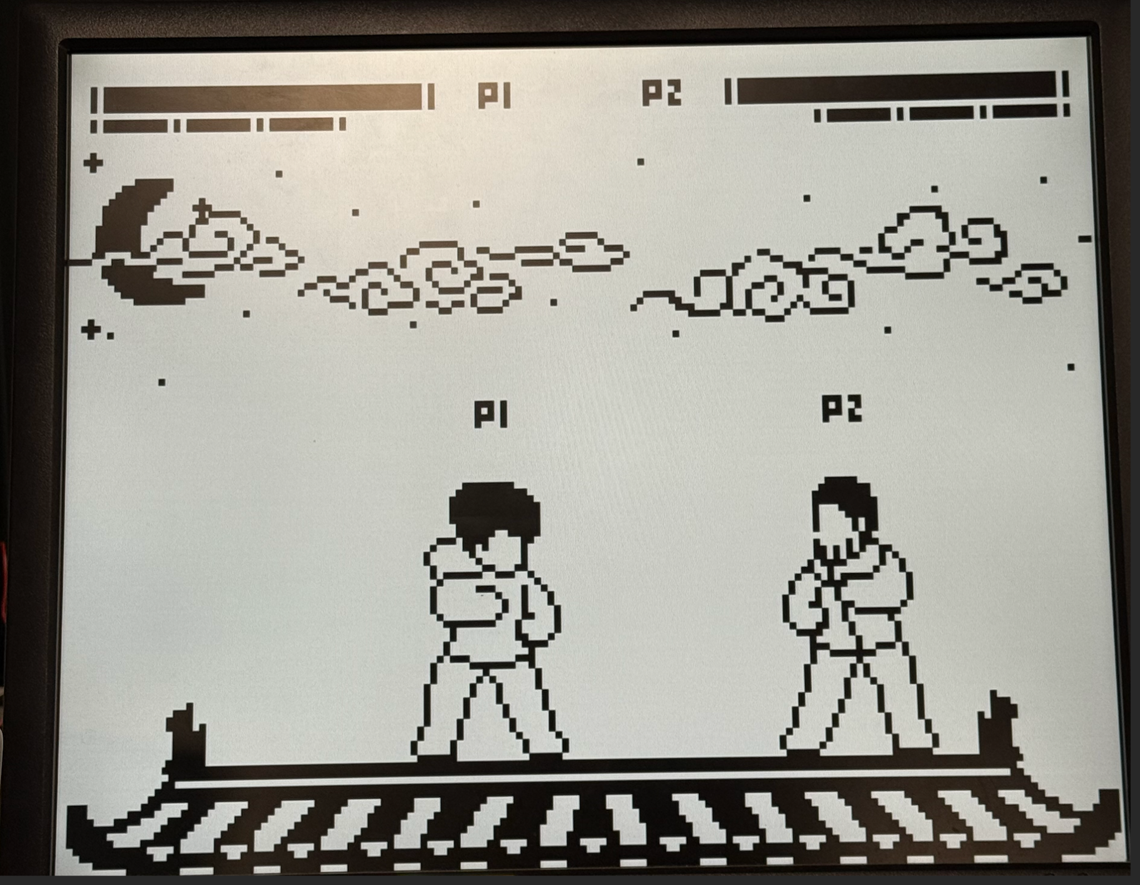

**Sprite Object Design**

Our game, Pico-Fight, is inspired by the 2D combat game Footsies, but rather than creating a replica, we aimed to develop something original. The player sprites were drawn over the original footsies sprites using Procreate (iOS) and PixelStudio (Android). The visual style is intentionally minimalist, limited to black and white. This allowed us to keep the same outlines however different heads and clothing models. To integrate these assets into our game, we wrote a Python script that converts each sprite into a two-dimensional C array.

For memory efficiency, our drawSprite function in C only takes the coordinates of either only black pixels or only white pixels depending on which one is fewer, and renders those, effectively outlining the sprite without needing to store full image data. Most of our animations consist of multiple frames – such as a five-frame attack sequence (Figure 1.). For each frame, we store an array of pixels (Figure 2.), with each pixel representing a displacement from the origin position of the player. This origin position is defined at the center of the player on the ground. Offsets are scaled by 4 to make sprites look bigger.

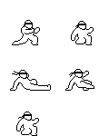 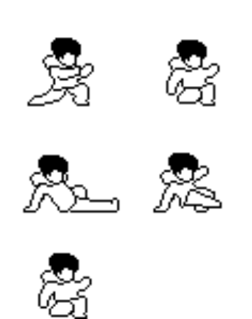

*Figure 1: Sample attack animation sprite sheets.*

*Left: reference sprite sheet from footsies Right: Our sprite sheet*

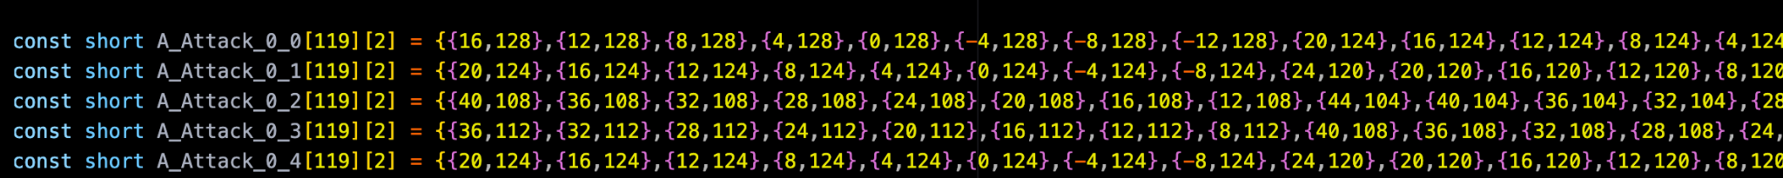

*Figure 2: Equivalent C arrays for each sprite in the attack animation (figure 1).*

*{x_offset, y_offset} from image bottom center, either for each black pixel or for each white pixel.*

*Offsets are scaled by 4 to make sprites look bigger.*

In addition to the player sprite sheets, the game also includes a variety of art for the various display screens and background parts. Each of these components was stored in similar C arrays and drawn modularly because many either need to move (eg. background clouds) or need to be switched around (eg. character select screen).

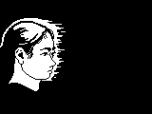

*Figure 3. Sample head on title screen.*

*Only the white part was recorded and rendered.*

Figure 4. The fillings of background clouds.

Converted to black for mass png-to-array conversion, but drawn in white on pico.

*Figure 4. The fillings of background clouds.*

*Converted to black for mass png-to-array conversion, but drawn in white on pico.*

**Background Music**

* Concept:
  + let 0=pause, 1=C, 2=D, 3=E, 4=F, 5=G, 6=A, 7=B, then the melody becomes   
    **4760 447760 2 4760 447760 2**
  + which represents **ECE4760 group 2**.
* notes : F4, B4, A4, 0, F3, F4, B3, B4, A4, 0, D5, F5, B4, A4, 0, F5, F4, B4, B3, A3, 0, D4
* duration (1 unit = 130ms): 2, 2, 2, 2, 1, 1, 1, 1, 1, 2, 1, 2, 2, 2, 2, 1, 1, 1, 1, 1, 2, 1

**Key mapping**

|  | **Pico**  **Keypads** | **Computer P1** | **Computer P2** | **Function** |
| --- | --- | --- | --- | --- |
|  | **2** | **W** | **O** | **Jump / Jump Block / Drop Attack** |
|  | **5** | **S** | **L** | **Crouch / Crouch Block** |
|  | **4** | **A** | **K** | **Move Left / Backward Block** |
|  | **6** | **D** | **:** | **Move Right / Backward Block** |
|  | **1** | **F** | **J** | **Stand Attack** |
|  | **3** | **R** | **U** | **Upward Attack** |
|  |  |  |  | **Crouch Attack** |
|  | **7** | **SPACE** | **SPACE** | **Pause** |
|  | **8** | **Q** | **I** | **Change Head** |
|  | **9** | **E** | **P** | **Change Clothes** |
|  | **0** | **ESC** | **Backspace** | **Back to Title** |

| **Attack** | **To Block** |
| --- | --- |
| **Stand Attack** | **Backward** |
| **Crouch Attack** | **Crouch** |
| **Drop Attack** | **Jump** |
| **Upward Attack** | **(Cannot block,**  **but easy**  **to dodge)** |

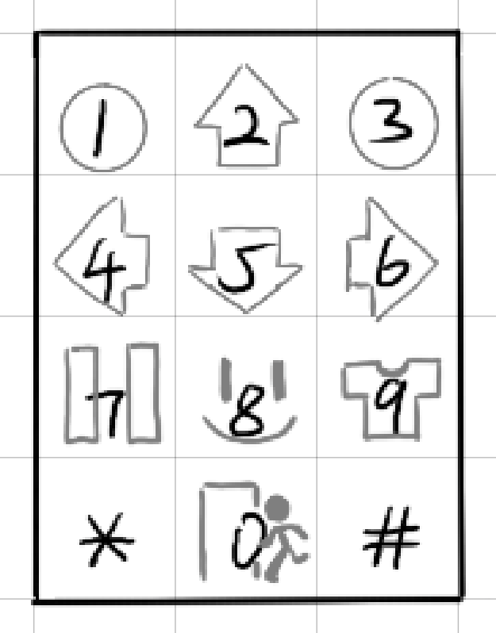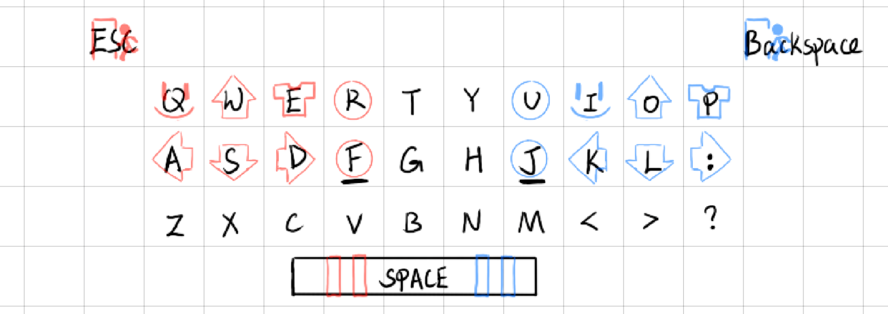

**Game Screens**

**Title Screen**

The title screen introduces our Pico-Fight game with our original game art. It features large illustrations of both players facing off, with smaller sprite versions beneath them in combat stances, creating a "Player A vs Player B" vibe to set the tone.

**Ready** **Screen**

The ready screen is designed for control testing. It includes a central window where players can press keys and receive both audio and visual feedback—for example, pressing key 2 triggers a sound and displays an up arrow, indicating upward movement. This helps players familiarize themselves with the controls before starting.

**Main Game Window**

This is where gameplay happens. Players control their characters in real-time, with visible health and shield bars. The main game screen displays all in-game interactions, animations, and player input.

**Pause Screen**

The pause screen also includes the control visualization window from the ready screen, allowing players to quickly recall key mappings mid-game without needing to restart or exit.

**Win Screen**

At the end of a match, the win screen announces the victorious player with a clear label and celebratory visuals, providing a satisfying conclusion to the fight.

**Game control flow**

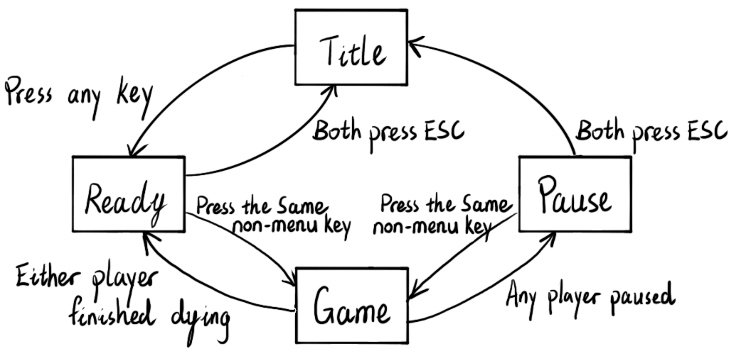

*Figure 5. Higher level UI transition logic.*

*Merging states for one-time rendering, and states pending input, into abstract states of visual screens.*

**

*Figure 6. Lower level UI transition logic.*

The core of Pico-Fight's control flow is driven by a state machine implemented through the ***ui_state*** variable. This state machine manages transitions between all major game screens and gameplay phases. The states are as follows: 0 initializes and renders the title screen; -1 waits for player input to transition to the ready screen; -2 displays control feedback for players to test their inputs; 2 runs the main game logic via the game_step() function; 3 assigns winners upon game completion, so that special sprites are displayed in the ready screen; and 4 pauses the game, allowing players to review controls mid-match. Transitions between these states are triggered by specific keypress combinations—for example, both players pressing the same key in a given range begins the match, while pressing ESC returns to the title screen.

Within the game state, we implement a substate machine that handles the state of each player and the interaction between them.

**Program Design**

**Hardware Overview**

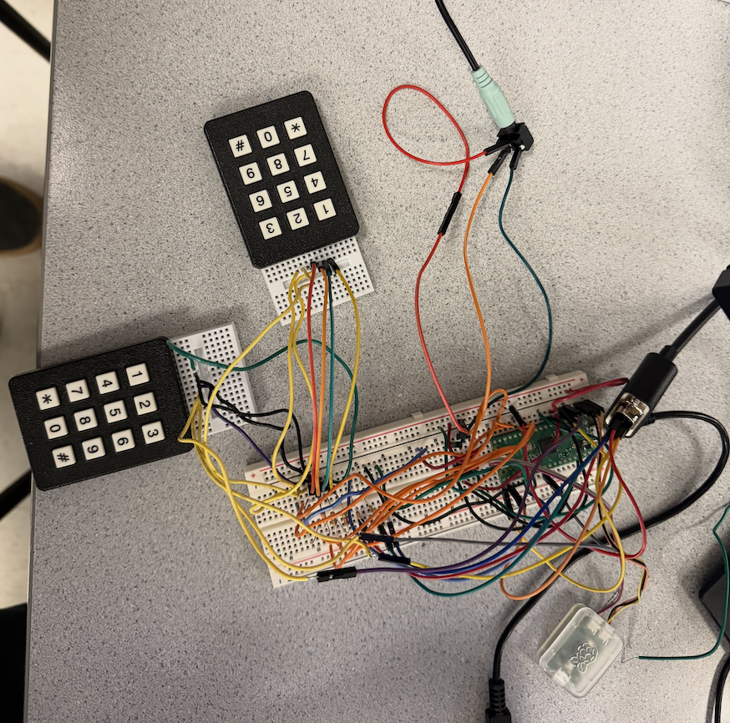

Figure x. Image of our hardware setup.

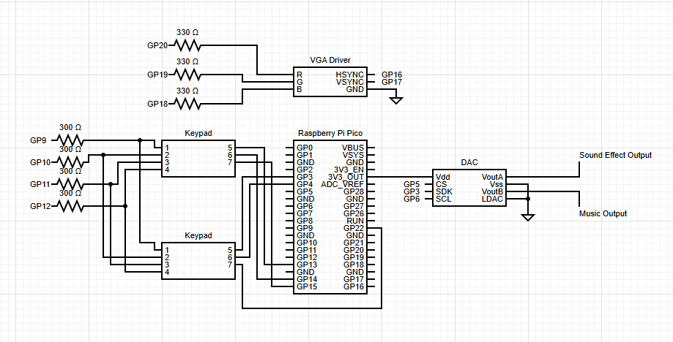

Figure x. Circuit diagram

The input to the game utilizes 2 keypads. These matrix-like keypads work by setting the columns of the matrix high one at a time. By then checking which GPIO receives an input we can determine which key is pressed at any time. In order to save GPIO pins, we decided to let both keypads share the same scan GPIO keys. That way, a single scan allows us to check both keypads.

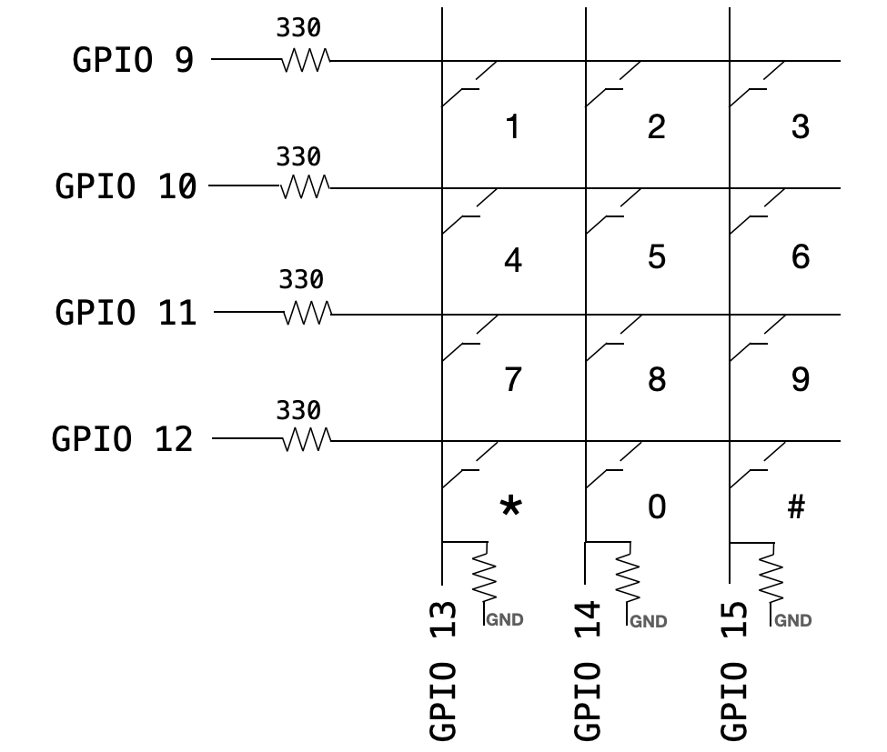

For the audio, we utilize both channels of the DAC to play sound effects and music. By utilizing stereo speakers, we can plug one DAC channel into the right speaker and one into the left. This minimizes the amount of interference between the sound effects and music.

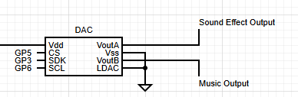

**Frames and Player State**

As with most fighting games, all of the timing is based on a frame timer system. Each frame corresponds to a step of the game. Within one frame, we must parse inputs, check for all interaction between the players then update the VGA screen. Utilizing frames also allows us to play the animations for the proper amount of time. For example the ‘hurt’ state in the figure below is a sequence of 4 sprites. When a player enters the ‘hurt’ state, we can simply draw one sprite per frame to complete the animation.

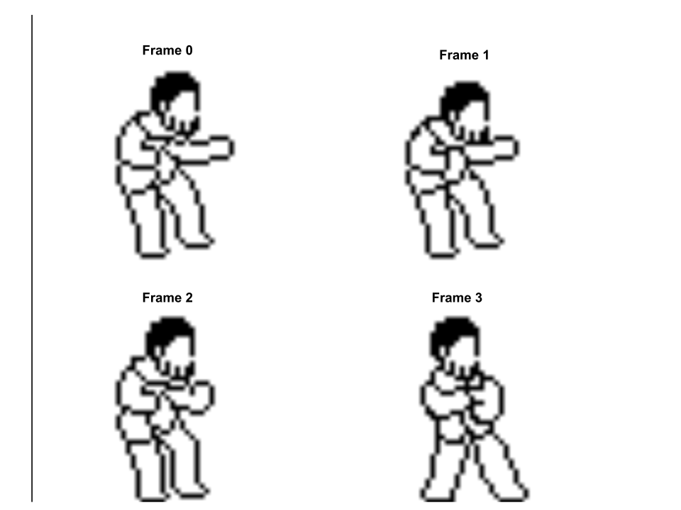

Each player is represented by a struct consisting of many variables making up the player's current state. The state of a player consists of information about the players game status (eg. health, shield, hitbox) as well as what animation should be played on a given frame (eg. state, frame). In order to play the right animation for each player on every frame, we needed to have a

**typedef struct**

**{**

**short x; //player's x position**

**short y; // player's y position**

**bool flip; //true: facing left. false: facing right**

**short state; //index of current animation. 0:idle, 1:stand attack, 2:forward, 3:backward, 4:hurt, 5:jump, 6:fall, 7:land, 8:crouch, 9:crouch attack, 10:upward attack, 11:die, 12:crouch guard, 13:stand guard**

**short frame; //index of frame in the current animation**

**short attack_hitbox; //index of hitbox for attack**

**short hp; //HP value. die when <=0.**

**Anim *head_anim; //pointer to the head animation array (i.e. characters)**

**Anim *body_anim; //pointer to the body animation array (i.e. clothes)**

**short body; //index of hitbox for body**

**short shield; //number of shields left**

**} player;**

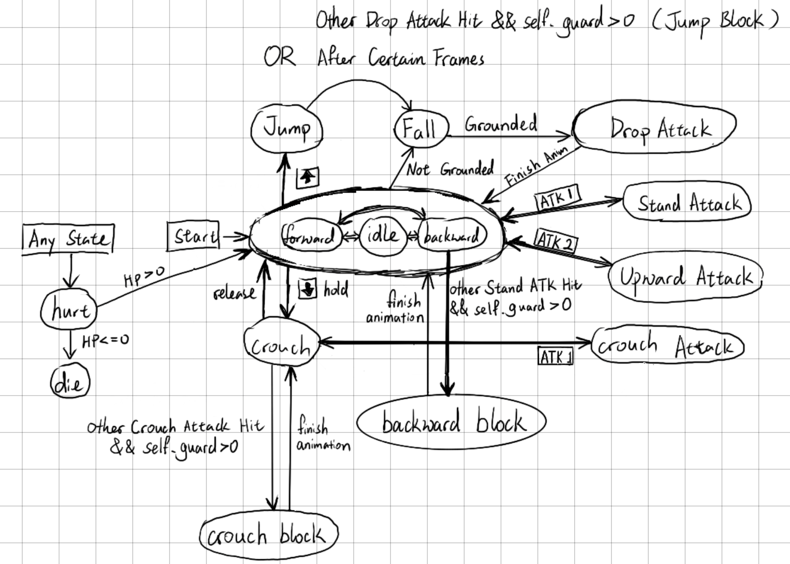

*Figure 7. State machine for the main game logic.*

**Playing sounds**

There are 3 types of sounds in our game:

1. background music from note frequency arrays through time interrupts,
2. sound effects from note frequency arrays through time interrupts (The beep in menu screens)
3. sound effects from .wav files through DMA.

To play arrays of note frequencies through time interrupts, similar to lab 1, we compute the current increment amount and update the accumulator according to current frequency:

phase_incr_main_0 = current_frequency * two32_fs and phase_accum_main_0 += phase_incr_main_0

The BGM and sound effects of notes share the same channel, so only one of them is being played. However, the counter for BGM does not pause while sound effects are being played, so that in theory it sounds as if the BGM is always playing and only happens to be unheard sometimes since the sound effect is too loud.

A set of complex sound effects utilize DMA channels to be played. These sound effects include the whooshing sound of attacks, the shielding sound and the hurt sound. In addition, at the start of each match the game will yell ‘*Fight*’, which is also an effect played through DMA. We accomplished this by first converting the .wav files of the sounds found on free sound effect websites into C arrays. Each sound effect was then assigned 2 DMA channels, a control channel and data channel.

hit_chan = dma_claim_unused_channel(true);

;

hitctrl_chan = dma_claim_unused_channel(true);

;

When the control channel is triggered, it is pointed to the data channel. The data channel then points to the location of the C array for the sound. The array is then transferred to SPI to the DAC playing the sound effect. The advantage of this is that the complex sound effects do not block the code and both complex sound effects and background music can be played simultaneously

**Collision / Hitbox detection**

One of the more challenging parts of implementation was checking hits and collisions. We utilize a hitbox system, assigning each move and player a set hitbox. This is done in order to determine if attacks are valid or if the players are colliding with one another. While we could have checked the pixel overlaps of the sprites themselves, we found it much simpler to draw bounding boxes around the players and the moves. This allowed us to simplify the detection of collision and attack hits by checking overlapping rectangles.

Each hitbox consists of {x_offset, y_offset, width, height}, where offsets are calculated from the bottom center of a player’s xy position. To check whether two hitboxes are overlapping, we wrote a function bool isOverlapping(short h1, short h2, short attacker), to which we pass the hitbox index of the attacker, hitbox index of the potential victim, and the player index of the attacker.

Inside this function, based on each player’s current position and whether each player is flipped, we first calculate the absolute positions of the x boundaries and y boundaries of the hitboxes as:

short h1y1, h1y2, h2y1, h2y2, h1x1, h1x2, h2x1, h2x2;

Then, we check:

bool x_overlap = (h1x1 >= h2x1 && h1x1 <= h2x2)

|| (h1x2 >= h2x1 && h1x2 <= h2x2)

|| (h2x1 >= h1x1 && h2x1 <= h1x2)

|| (h2x2 >= h1x1 && h2x2 <= h1x2);

bool y_overlap = (h1y1 >= h2y1 && h1y1 <= h2y2)

|| (h1y2 >= h2y1 && h1y2 <= h2y2)

|| (h2y1 >= h1y1 && h2y1 <= h1y2)

|| (h2y2 >= h1y1 && h2y2 <= h1y2);

The final result is (x_overlap && y_overlap).

// hitboxes: 0: stand body, 1: stand hit, 2: stand feet, 3: stand head, 4: drop hit, 5: crouch body, 6: crouch hit, 7: upward hit

const hitbox hitboxes[] = {{28, 160, 60, 160}, {-28, 128, 84, 56}, {28, 0, 60, 0}, {28, 160, 60, 0}, {28, 0, 60, 20}, {28, 124, 60, 124}, {-28, 28, 72, 28}, {8, 200, 32, 40}};

Figure x. hitboxes array.

each hitbox consists of {x_offset, y_offset, width, height},

where offsets are calculated from the bottom center of a player.

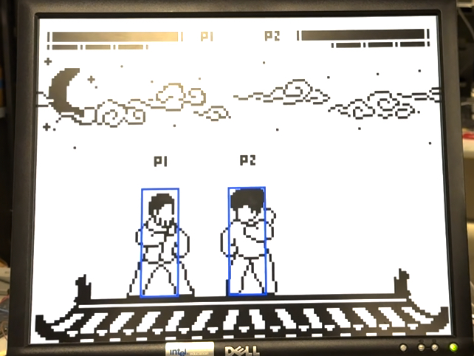

Figure x. Normal bounding box

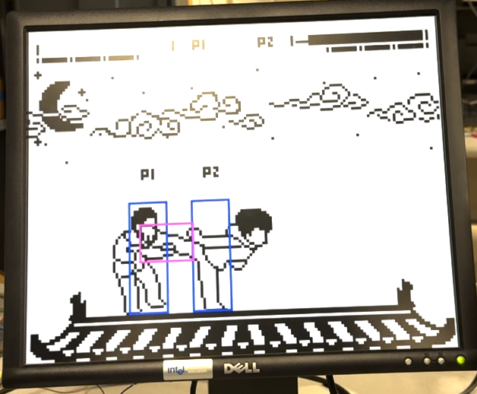

Figure x. Bounding box for kick

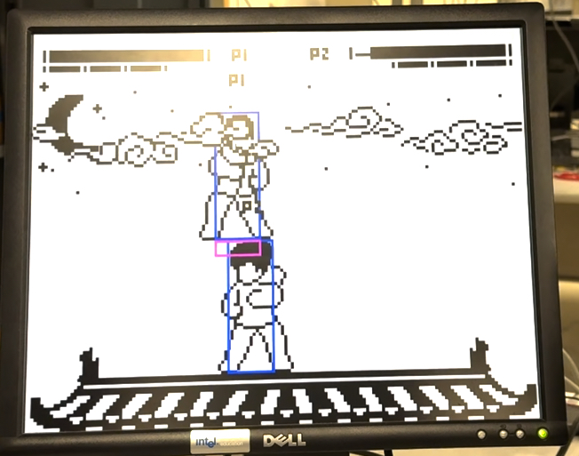

Figure x. Bounding box for jump attack

**Results**

Overall we are very satisfied with the result. An initial concern of ours was meeting the timing deadline of 10FPS as we are performing many checks and VGA drawings however we did not have any problems throughout our development. While occasionally we would suffer from noise in the sound effects, we found that after splitting the sound effects and music into different speakers much of it was reduced.

**Playtesting**

Of course because this is a video game, the goal is to make it fun. We enjoyed playing it for many rounds and had another group come play as well. The experience is smooth and fairly intuitive once you get used to the controls. The main feedback we received was with the balancing of the game, where certain strategies such as crouch attack were too strong.

**Conclusion**

We are very happy with how the game turned out. We essentially created what we set out to do in the proposal which was just a fun fighting game that ran smoothly on the Pico. In the future however we would like to add more moves and features which we had initially thought of. For example we wanted to add ‘combo’ moves or extra movement options such as dashing.

While we did not use any code in the public domain, we did draw over art from the ‘Footsies’ video game. Footsies is an open source game under the GPL-3.0 license allowing for derivative works.

**Appendix A: Notices**

The group approves this report for inclusion on the course website.

The group approves the video for inclusion on the course youtube channel.

**Appendix B: Parts List**

1x VGA Screen

2x Keypad

1x Raspberry Pi Pico

1x DAC

1x Speaker

Jumper Cables

**Appendix C: Code**

<https://github.com/asun121/ece4760-final-project>

**Appendix D: ChatGPT Generated Code for a Computer Version**

<https://github.com/CMDHL/ece4760-web-demo>

<https://cmdhl.github.io/ece4760-web-demo/>